**University of Michigan – Dearborn**

**CIS 150 – Computer Science 1**

**Lab# 3**

Quan Le

[lmmquan@umich.edu](mailto:lmmquan@umich.edu)

January 30, 2024

**Table Content**

Contents

Question 1 3

Source Code 3

Screenshots 3

Question 2 4

Test Cases 4

Source Code 5

Screenshots 5

Question 3 6

Test Cases 6

Source Code 6

Screenshots 6

Question 4 7

Test Cases 7

Source Code 8

Screenshots 8

# Question 1

## Source Code

The source code for this question has been uploaded to Canvas as lab3q1.cpp.

## Screenshots

Test Case for x = 15:

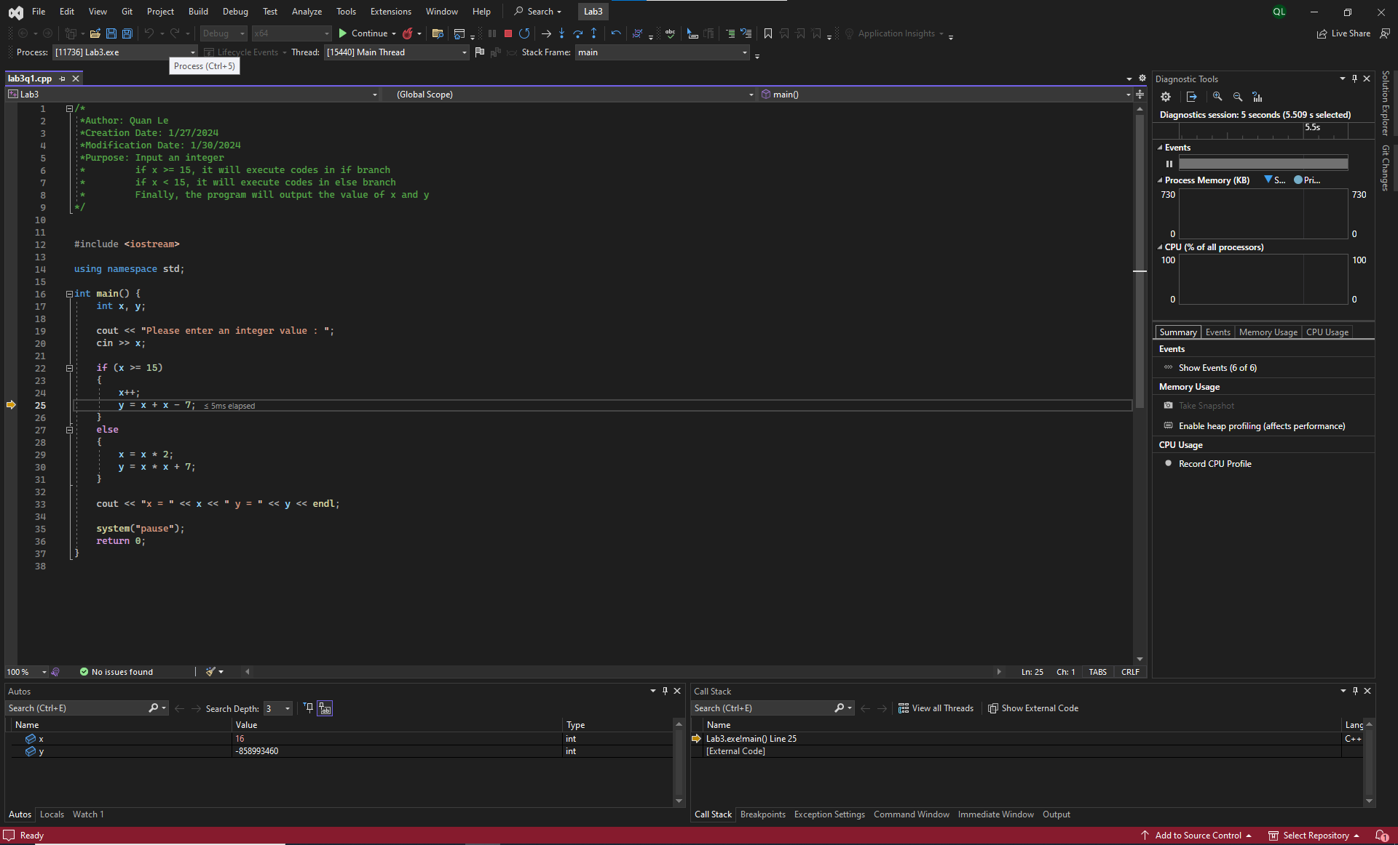

Test Case for x = 14

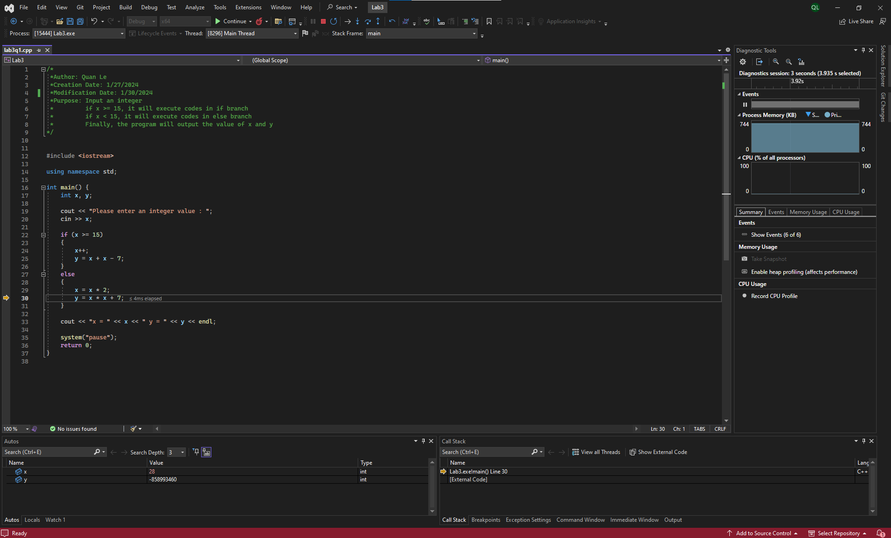

# Question 2

## Test Cases

|  |  |  |  |  |  |
| --- | --- | --- | --- | --- | --- |
| Test # | Valid / Invalid Data | Description of test | Input Value | Actual Output | Test Pass / Fail |
| 1 | Valid | The input for name is Quan Le and the input for age is 20.  The output should be “Congratulations Quan Le! Your vote registration was successfully processed.” | name = “Quan Le”  age = 20 | Congratulations Quan Le! Your vote registration was successfully processed. | Pass |
| 2 | Valid | The input for name is ABCDE and the input for age is 18.  The output should be “Congratulations ABCDE! Your vote registration was successfully processed.” | name = “ABCDE”  age = 18 | Congratulations ABCDE! Your vote registration was successfully processed. | Pass |
| 3 | Valid | The input for name is 123456 and the input for age is 10.  The output should be “You are not eligible to vote 123456.” | name = “123456”  age = 10 | You are not eligible to vote 123456. | Pass |
| 4 | Valid | The input for name is A1B2C3 and the input for age is -10.  The output should be “You are not eligible to vote A1B2C3.” | name = “A1B2C3”  age = -10 | You are not eligible to vote A1B2C3 | Pass |

## Source Code

The source code for this question has been uploaded to Canvas as lab3q2.cpp.

## Screenshots

Test Case 1:

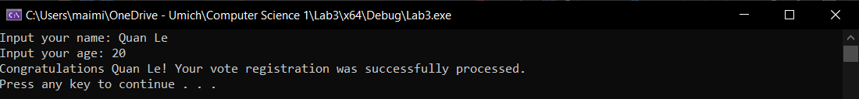

Test Case 2:

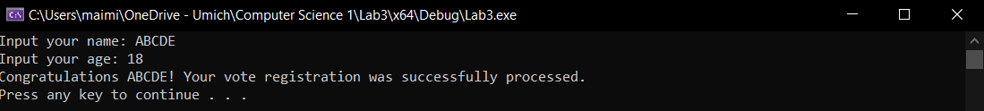

Test Case 3:

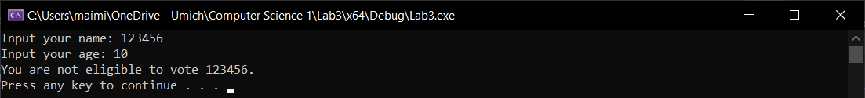

Test Case 4:

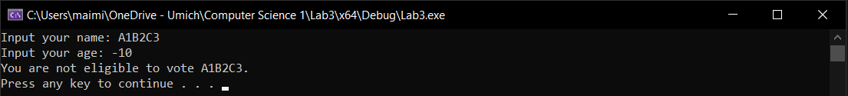

# Question 3

## Test Cases

|  |  |  |  |  |  |
| --- | --- | --- | --- | --- | --- |
| Test # | Valid / Invalid Data | Description of test | Input Value | Actual Output | Test Pass / Fail |
| 1 | Valid | The input for hours worked is 30.0 and the input for pay rate is 10.0.  The output should be “Gross pay for the week is $300” | hoursWorked = 30.0  payRate = 10.0 | Gross pay for the week is $300 | Pass |
| 2 | Valid | The input for hours worked is 50.0 and the input for pay rate is 10.0.  The output should be “Gross pay for the week is $550” | hoursWorked = 50.0  payRate = 10.0 | Gross pay for the week is $550 | Pass |
| 3 | Valid | The input for hours worked is 0.0 and the input for pay rate is 0.0.  The output should be “Gross pay for the week is $0” | hoursWorked = 0.0  payRate = 0.0 | Gross pay for the week is $0 | Pass |
| 4 | Valid | The input for hours worked is 40.0 and the input for pay rate is 20.0.  The output should be “Gross pay for the week is $800” | hoursWorked = 40.0  payRate = 20.0 | Gross pay for the week is $800 | Pass |

## Source Code

The source code for this question has been uploaded to Canvas as lab3q3.cpp.

## Screenshots

Test Case 1:



Test Case 2:



Test Case 3:



Test Case 4:

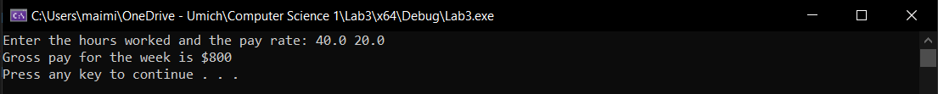

# Question 4

## Test Cases

|  |  |  |  |  |  |
| --- | --- | --- | --- | --- | --- |
| Test # | Valid / Invalid Data | Description of test | Input Value | Actual Output | Test Pass / Fail |
| 1 | Valid | The input for a is 6, the input for b is -5 and the input for c is -4.  The output should be 1.333333 and -0.500000 | a = 6  b = -5  c = -4 | Root 1 is 1.333333  Root 2 is -0.500000 | Pass |
| 2 | Valid | The input for a is 1, the input for b is 0 and the input for c is -8.  The output should be 2.828427 and -2.828427 | a = 1  b = 0  c = -8 | Root 1 is 2.828427  Root 2 is -2.828427 | Pass |
| 3 | Valid | The input for a is 0, the input for b is 3 and the input for c is 5.  The output should be “No real root” | a = 0  b = 3  c = 5 | No real root | Pass |
| 4 | Valid | The input for a is 1, the input for b is 5 and the input for c is -5.  The output should be 0.854102 and -5.854102 | a = 1  b = 5  c = -5 | Root 1 is 0.854102  Root 2 is -5.854102 | Pass |

## Source Code

The source code for this question has been uploaded to Canvas as lab3q4.cpp.

## Screenshots

Test Case 1:

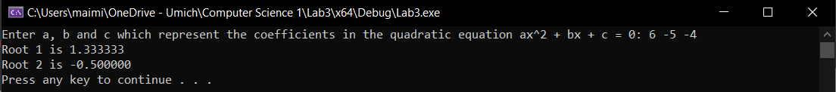

Test Case 2:

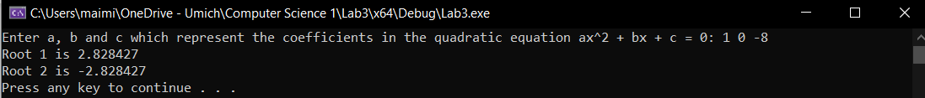

Test Case 3:



Test Case 4:

